ECSE 543: Assignment 3

Razi Murshed

260516333

# Question 1

## Part A

The code for the interpolation of this polynomial was done by the function “Lagrange.m”. A plot of the 6 points passed into the function Lagrange is shown below –

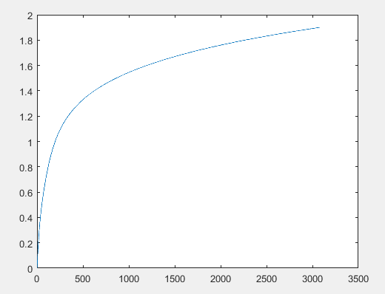

As the curve seems pretty smooth it seems like the result is plausible and is a good representation.

## Part b

When the function runs over the points B = [0, 1.3, 1.4, 1.7, 1.8, 1.9] we see the following plot –

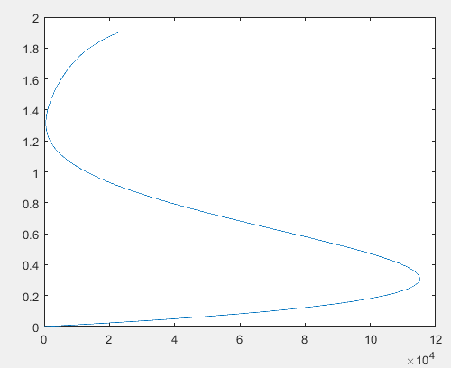

It can be seen that this graph does not look anything like a H versus B graph and therefore not a plausible representation.

## Part C

If we happen to know both function values and first derivative values at a set of data points, then piecewise cubic Hermite interpolation can reproduce those data. But since we are not given the derivative values, we need to define the slopes somehow. However, we would have to do this for two types of points, the edge points such as the start and end points and also for the internal points. For the internal points we calculate this by finding the differences in the x-axis and creating a delta by dividng the differences in the x points with the difference in the y-points. We can then use this delta along with the differences in the x-axis to form the slopes. For the end points we can find the slopes by interpolating using the deltas between the first and second points and the second last and last points using their deltas. The codes for cubic hermite interpolation can be found in ‘cubicHermiteInterpolation.m’ and ‘calculateSlopeInternal.m’. The following plot is found with B = [0.0, 0.2, 0.4, 0.6, 0.8, 1.0] –

For B = [0, 1.3, 1.4, 1.7, 1.8, 1.9] we get the following –

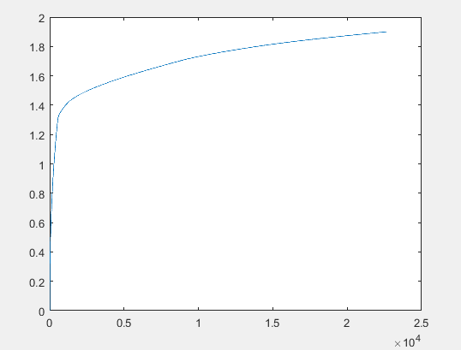

We can see that it produces a better curve for points that are widely separated which the Lagrange fails to do.

# Question 2

## part a

From the following circuit we determine voltages at the two nodes by following the conventions mentioned in the diagram –

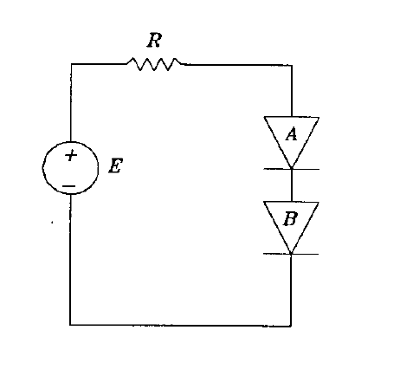

V2

V1

We find the two equations of F to be –

$$F_{1}=v_{1}-E+RI_{sA}\left(e^{\frac{v_{1}-v_{2}}{25m}}-1\right)=0$$

$$F_{2}=0=I_{sA}\left(e^{\frac{v_{1}-v_{2}}{25m}}-1\right)-I_{sB}\left(e^{\frac{v_{2}}{25m}}-1\right)$$

## part B

We modelled the circuit in “ElectricCircuit.m” and the solver was written in the file “newRapCircuit.m”. It took us 5 iterations to get to our selected error margin $ε_{k}= {10}^{-6}$. The final voltages were found to be V = [0.183430837132538, 0.0832765631282870]. The following shows a plot of number of iterations against difference and we can see that the convergence is actually quadratic.

